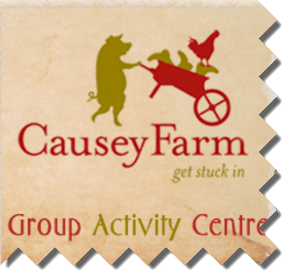

CLEFT LIP AND PALATE ASSOCIATION FAMILY ACTIVITY DAY 2019

Saturday 15th June 2019 from 10:00am to 4pm

Causey Farm, Girley, Navan, Co. Meath

Please complete the attached booking form and post to CLAPAI, c/o 4 Wolverton Glen Dalkey, Co. Dublin or email info@cleft.ie or
book on Eventbrite Booking for Family Day 2019

Closing date for replies Monday 11th June 2019.

If for any reason you do not get a confirmation of your booking from us please contact us at 087 1319803
Family Name | Family Address |  | Contact Number
Name | Adult /Child | Child’s Age
Special Needs |  | Transport Help ?

Please check www.cleft.ie for updates or follow us on Facebook
Admission is free but donations gratefully accepted

We look forward to seeing you for another great family day …!

